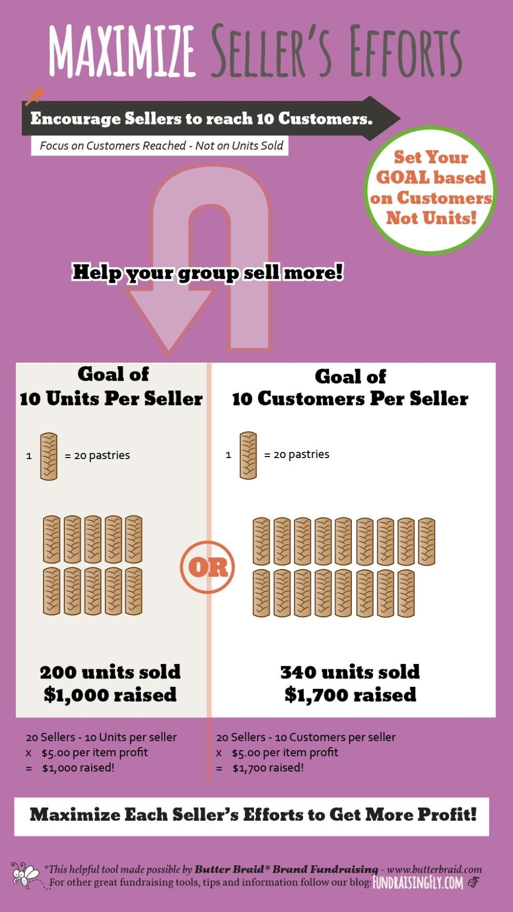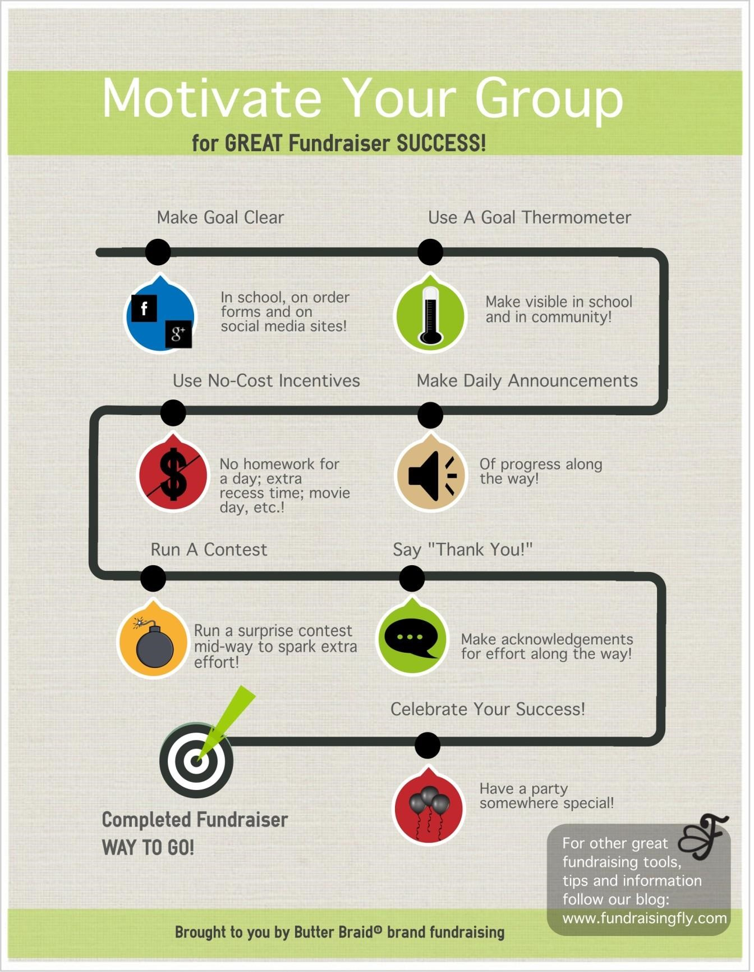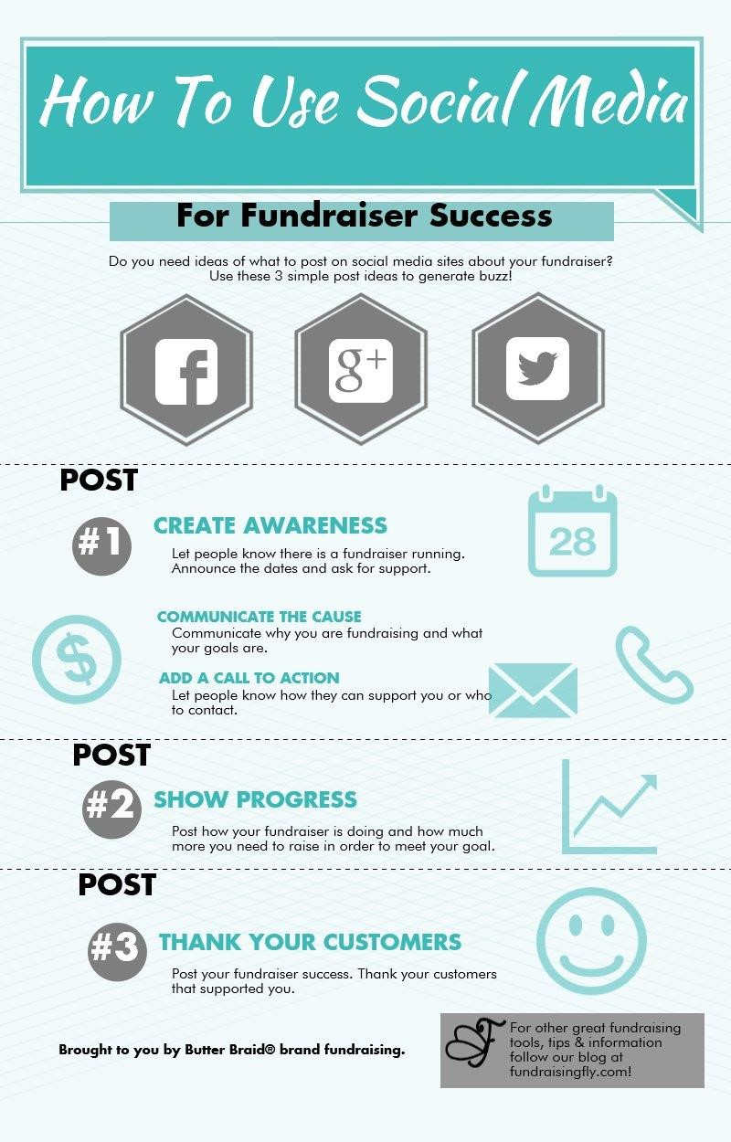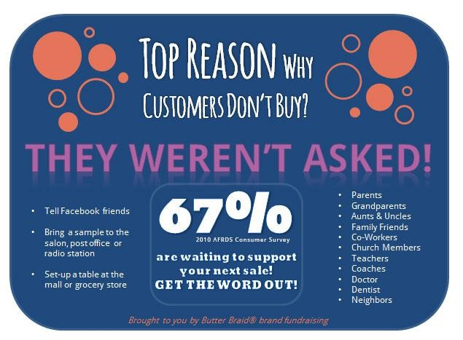

Thank you for choosing Butter Braid Fundraising!

As seen below, the biggest reason that people do not buy from your

fundraiser, is that they were not asked! Hard to believe, but that is also

what we observe all the time when out talking to potential customers.

We strongly believe that you will reap an increase in sales with well

placed communications via social media, newspaper, community or

organization newsletter, radio, or anything unique and local. The

following links are available to you for inspiration. The

Fundraisingfly

blog has a lot of great ideas, and feel free to give us a call to help

brainstorm.

Joel at 513.319.1990

Liberty Fundraising website:



[www.libertyfrc.co](http://www.libertyfrc.co)m

[-](https://www.facebook.com/pages/Success-N-Fundraising-llc/501568369891471)

[-](https://www.facebook.com/pages/Success-N-Fundraising-llc/501568369891471)

Butter Braid Fundraising Website:

<http://butterbraid.com>

[/](http://butterbraid.com/)

Butter Braid Fundraising Blog:

[http://fundraisingfly.com](http://fundraisingfly.com/)

[/](http://fundraisingfly.com/)

Butter Braid Fundraising Facebook:

[https://www.facebook.com/ButterBraidBrandFundraisin](https://www.facebook.com/ButterBraidBrandFundraising)

[g](https://www.facebook.com/ButterBraidBrandFundraising)